# Hyperdoc Set-Up Directions

Edit the template on the following page to create your own weekly Hyperdoc. Reference the example on the first row (“Monday”) to get started. After customizing the Hyperdoc template with relevant details and links, disseminate it to all students.

Find more [subject-specific and grade-specific Hyperdocs](https://hyperdocs.co/blog/posts/hyperdocs-templates-for-getting-started) online.

### Step-By-Step Instructions

1. **Customize the Hyperdoc title.**
2. 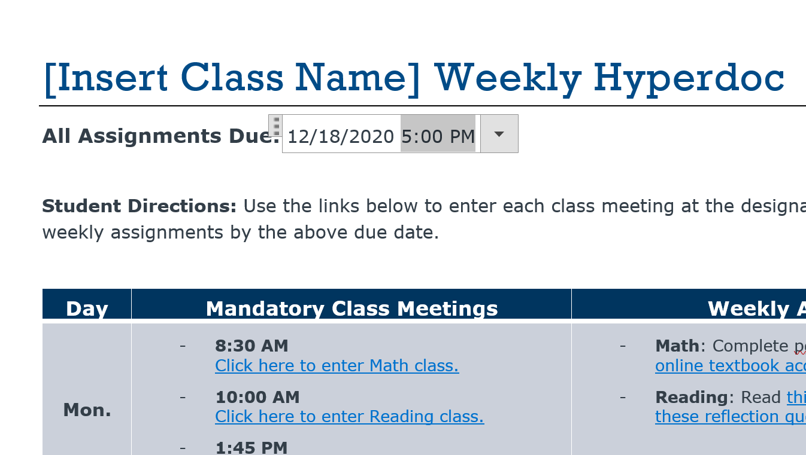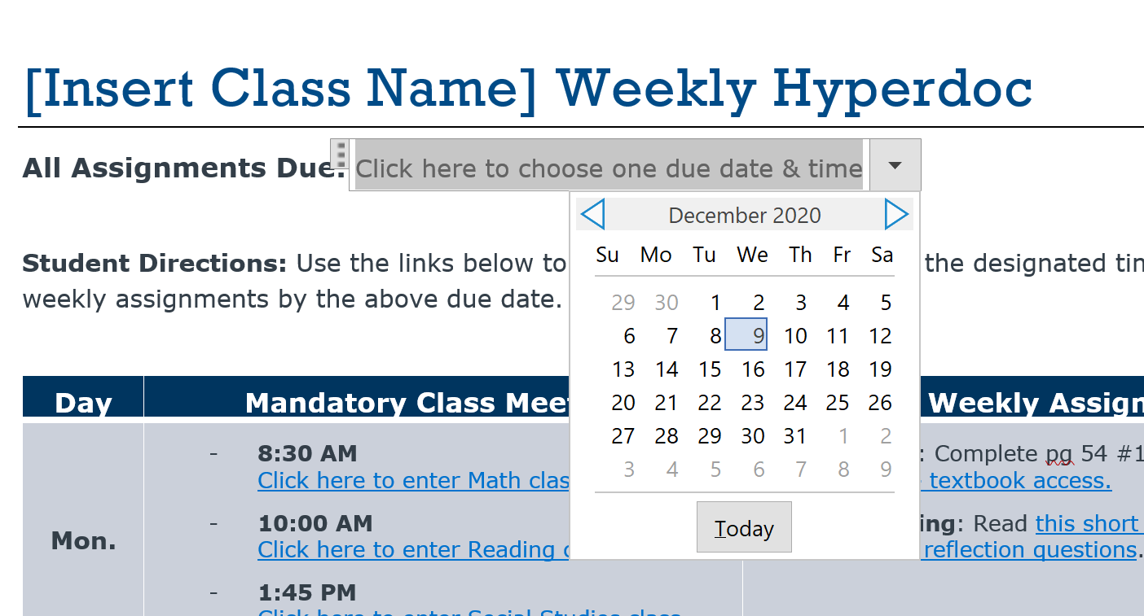**Choose a due date** for the Hyperdoc assignments by selecting a date and time from the drop-down calendar. See the example below.

*Manually edit the time, if desired.*

*Click the drop-down arrow and choose a due date.*

1. 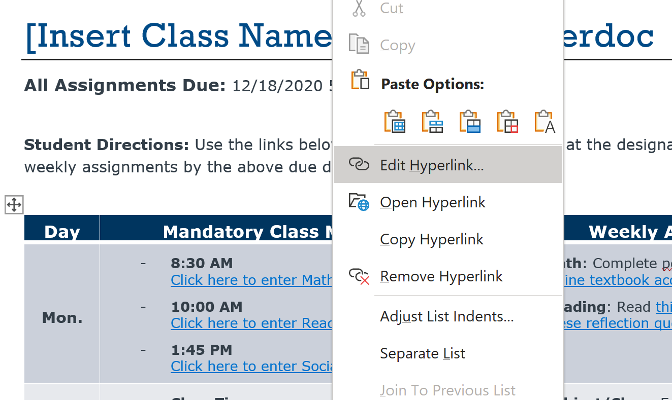**Insert all class meetings** for the week.

*To edit the class meeting hyperlink, right-click on the hyperlink and select “Edit Hyperlink.”*

1. **Insert all ongoing assignments** for the week. Add hyperlinks to relevant materials where necessary.

# [Insert Class Name] Weekly Hyperdoc

**All Assignments Due:** Click here to choose one due date & time

**Student Directions:** Use the links below to enter each class meeting at the designated time. Complete all weekly assignments by the above due date.

|  |  |  |
| --- | --- | --- |
| Day | Mandatory Class Meetings | Weekly Assignments |
| **Mon.** | * **8:30 AM** Click here to enter Math class. * **10:00 AM** Click here to enter Reading class. * **1:45 PM** Click here to enter Social Studies class. | * **Math**: Complete pg 54 #1-10. Click here for online textbook access. * **Reading**: Read this short story, then respond to these reflection questions. |
| **Tues.** | * **Class Time:** Insert class meeting hyperlink * **Class Time:** Insert class meeting hyperlink * **Class Time:** Insert class meeting hyperlink | * **Subject/Class:** Enter assignment directions. [Edit hyperlink](link) for necessary materials. * **Subject/Class:** Enter assignment directions. [Edit hyperlink](link) for necessary materials. |
| **Wed.** | * **Class Time:** Insert class meeting hyperlink * **Class Time:** Insert class meeting hyperlink * **Class Time:** Insert class meeting hyperlink | * **Subject/Class:** Enter assignment directions. [Edit hyperlink](link) for necessary materials. * **Subject/Class:** Enter assignment directions. [Edit hyperlink](link) for necessary materials. |
| **Thurs.** | * **Class Time:** Insert class meeting hyperlink * **Class Time:** Insert class meeting hyperlink * **Class Time:** Insert class meeting hyperlink | * **Subject/Class:** Enter assignment directions. [Edit hyperlink](link) for necessary materials. * **Subject/Class:** Enter assignment directions. [Edit hyperlink](link) for necessary materials. |
| **Fri.** | * **Class Time:** Insert class meeting hyperlink * **Class Time:** Insert class meeting hyperlink * **Class Time:** Insert class meeting hyperlink | * **Subject/Class:** Enter assignment directions. [Edit hyperlink](link) for necessary materials. * **Subject/Class:** Enter assignment directions. [Edit hyperlink](link) for necessary materials. |