|  |  |
| --- | --- |
|  | PAE Forum |

Employer Lead Scoring Rubric

### How to Use This Tool

Even institutions that are able to identify warm leads for partnership struggle to 1. prioritize among those partnerships and 2. convey the full scope of institutional offerings with comprehensive messaging.

By bringing together stakeholders at your institution to share data about existing employer relationships, you are able to not only build a holistic picture of previous engagement, but also drill deeply into existing data to determine what measures correlate with partnership success. Since employer engagement is a time-intensive process, prioritizing leads can ensure B2B marketing efforts remain focused on high-conversion prospect leads.

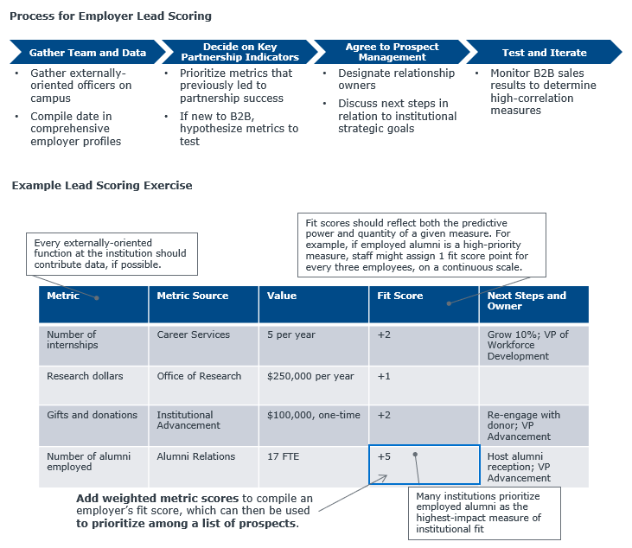The following process and table illustrate how you can leverage a lead scoring rubric to gather data and monitor metrics correlated with B2B success. While this process functions best as part of a cross-silo collaboration on campus, it is still effective as an exercise within units or colleges. Bring together data to create an employer profile first, then determine weighted scores based on correlation with future partnership. Score weighting can continually be reassessed and tweaked as your B2B business evolves and matures.

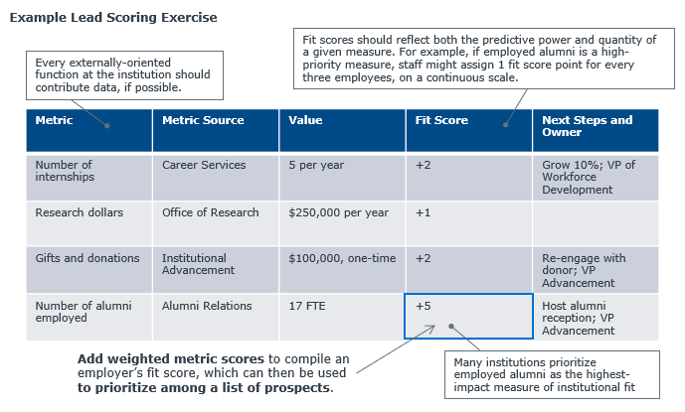

|  |  |  |  |  |
| --- | --- | --- | --- | --- |
| **Metric** | **Metric Score** | **Value** | **Fit Score** | **Next Steps and Owner** |
|  |  |  |  |  |
|  |  |  |  |  |
|  |  |  |  |  |
|  |  |  |  |  |
|  |  |  |  |  |
|  |  |  |  |  |
|  |  |  |  |  |
|  |  |  |  |  |
|  |  |  |  |  |
|  |  |  |  |  |
|  |  |  |  |  |
|  |  |  |  |  |
|  |  |  |  |  |
|  |  |  |  |  |
|  |  |  |  |  |

### Your Employer Lead Scoring Rubric