Priorities Mapping Exercise

List out your institution’s strategic priorities in the column to the left, then write your corresponding strategic objectives. Then, identify the metric most closely related to each individual objective. (Note: It might not be possible to have a metric for every objective.) The framework below depicts how to effectively cascade broad strategic priorities into space productivity-specific objectives, metrics, and initiatives.

#### Framework to Map Metrics to Institutional Strategic Priorities

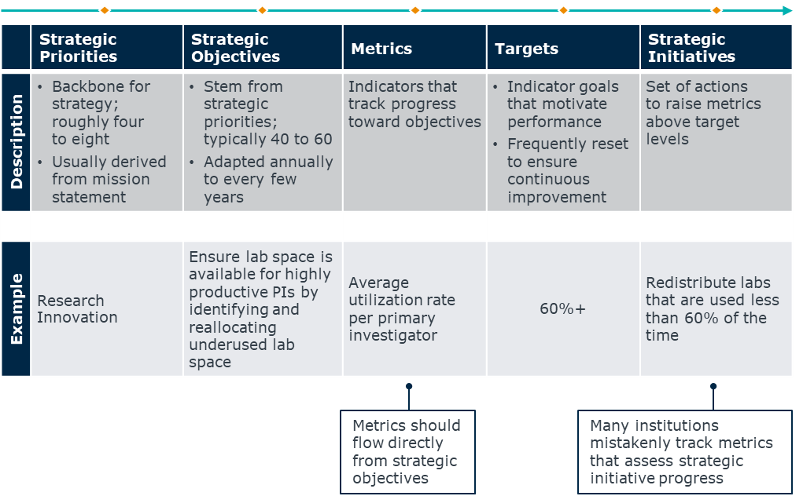

Note that you do not have to fill out the Targets and Strategic Initiatives columns yet; however, thinking through the strategic initiatives is helpful because it can help you differentiate between metrics that advance the objective versus those that track progress against the initiative. In this example, tracking the lab utilization rate per primary investigator is the key metric.

**Use the fillable worksheets on the following pages to complete the exercise for your institution’s strategic priorities.**

### Priorities Mapping Exercise

|  |  |  |  |  |
| --- | --- | --- | --- | --- |
| Strategic Priorities | Strategic Objectives | Metrics | Targets | Strategic Initiatives |
|  |  |  |  |  |
|  |  |  |  |  |
|  |  |  |  |  |
|  |  |  |  |  |
|  |  |  |  |  |
|  |  |  |  |  |
|  |  |  |  |  |

|  |  |  |  |  |
| --- | --- | --- | --- | --- |
| Strategic Priorities | Strategic Objectives | Metrics | Targets | Strategic Initiatives |
|  |  |  |  |  |
|  |  |  |  |  |
|  |  |  |  |  |
|  |  |  |  |  |
|  |  |  |  |  |
|  |  |  |  |  |
|  |  |  |  |  |